How to Download “Attendance”
Note: Make sure you are logged in to BrightSpace (ask a campus Principal to help you with this).
Download all “Attendance” files (in .csv format) and copy to USB’s “Attendance” folder.

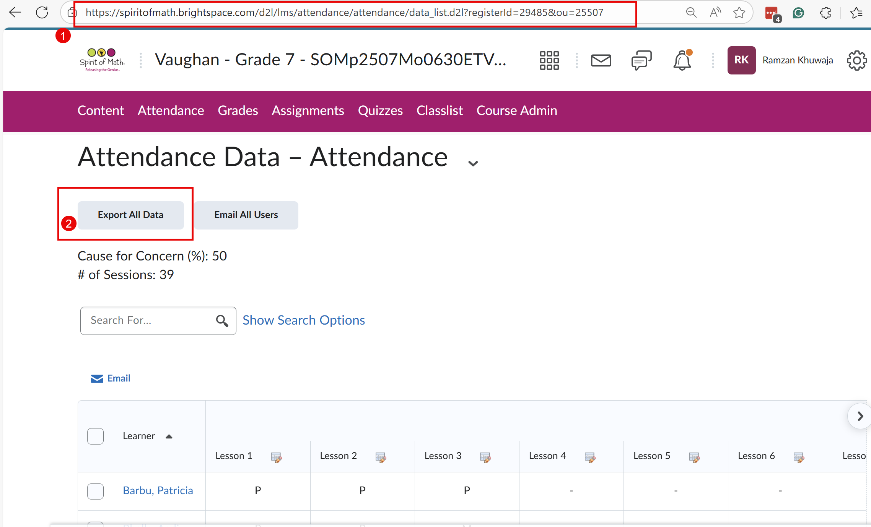
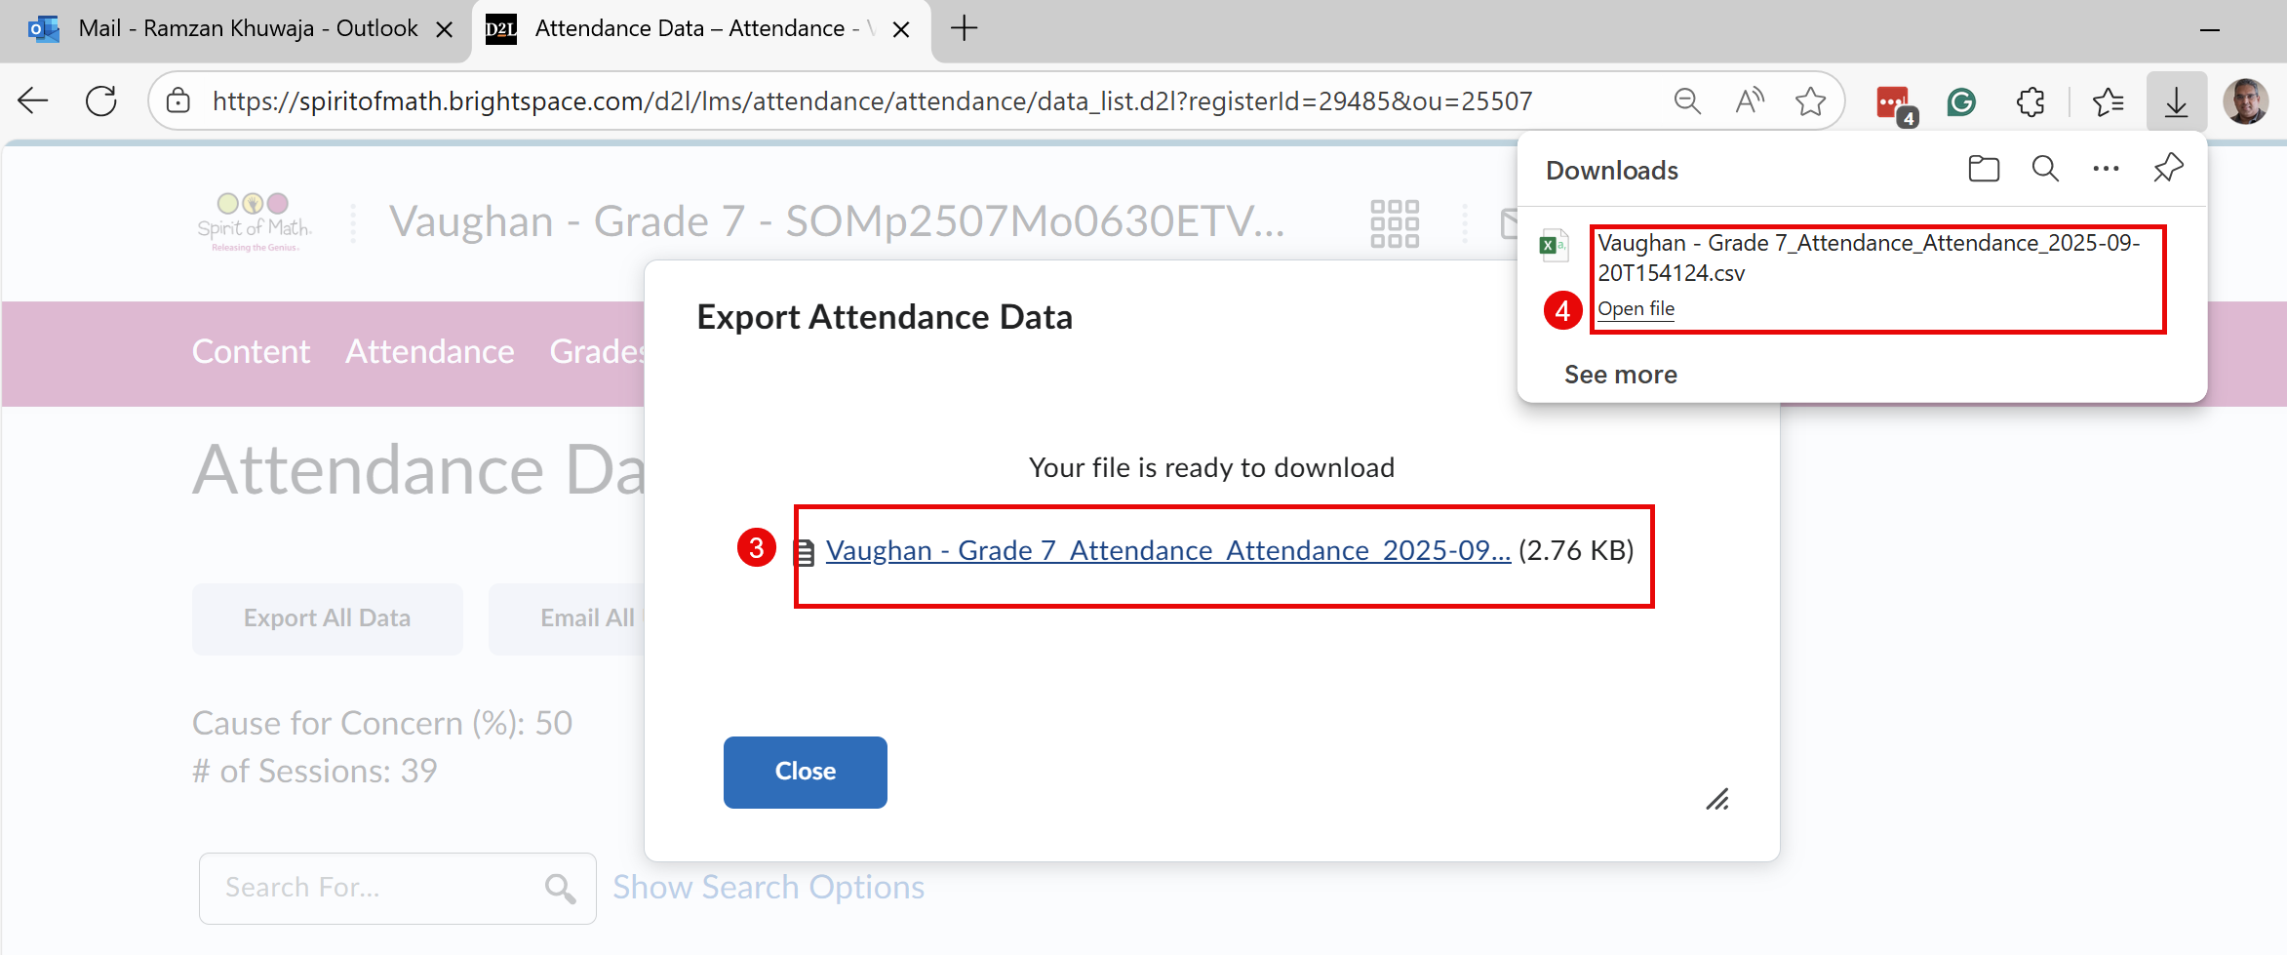

How to Download “Grades”
Note: Make sure you are logged in to BrightSpace (ask a campus Principal to help you with this).
Download all “Grades” files (in .csv format) and copy to USB’s “Grades” folder.

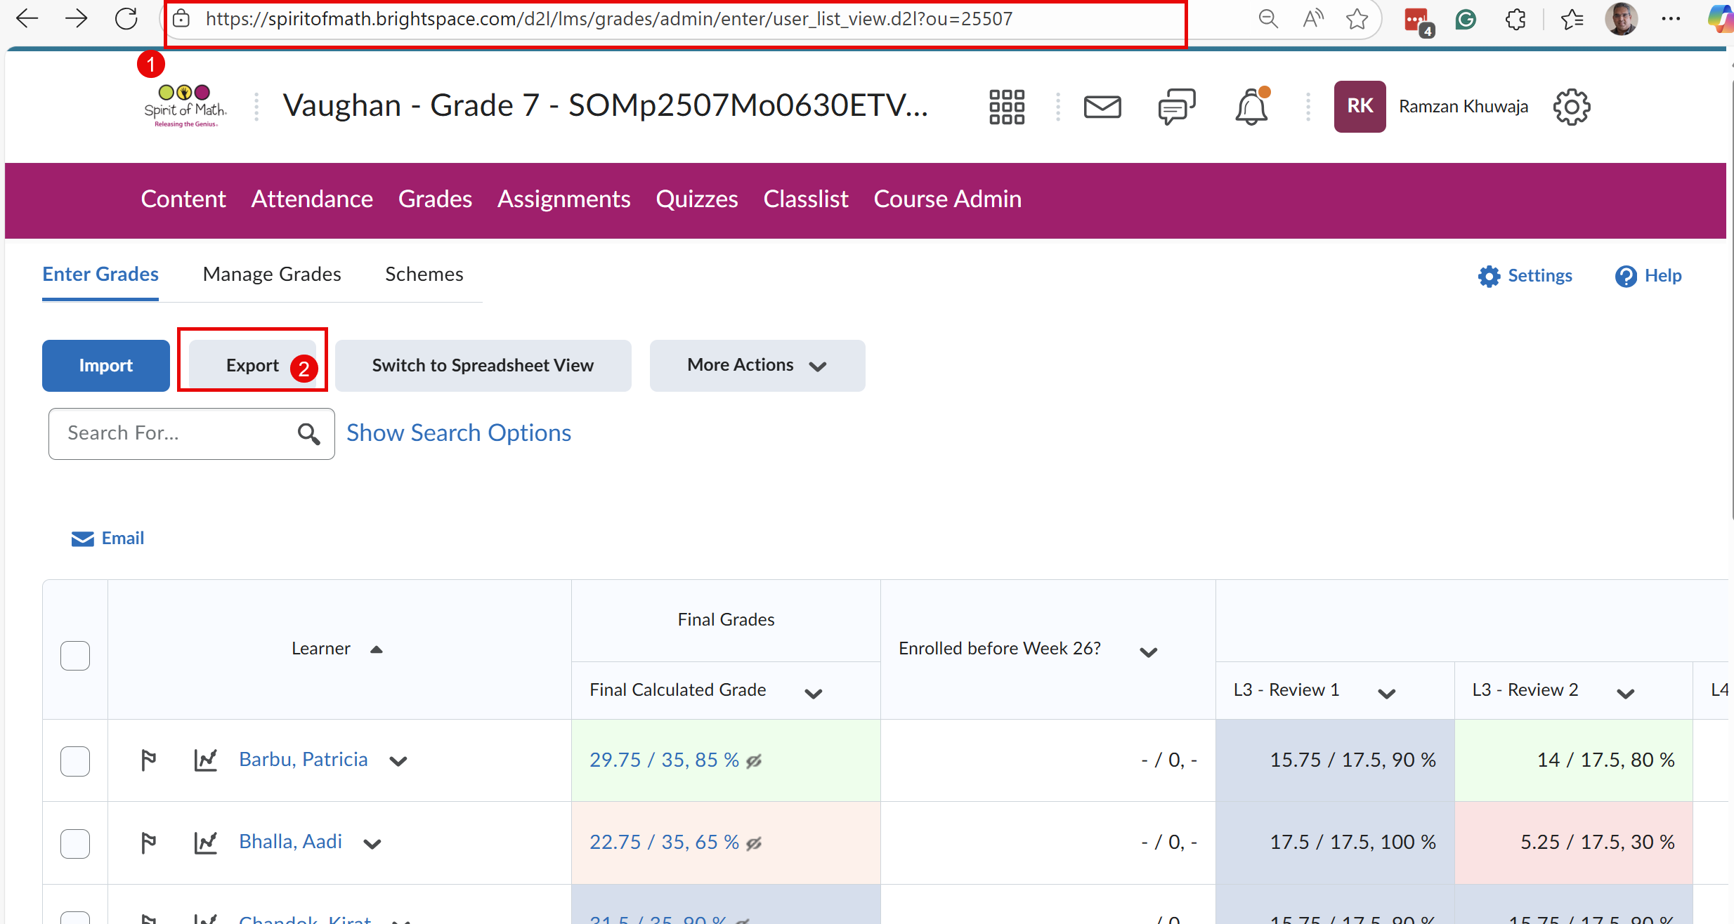

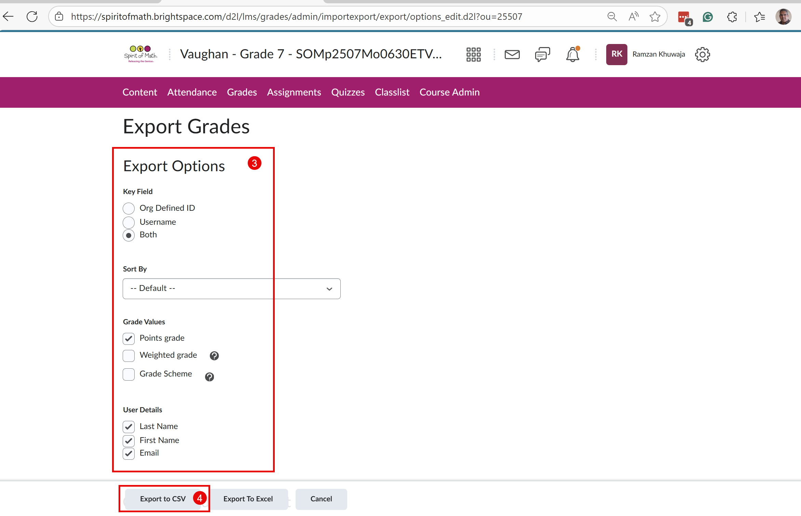
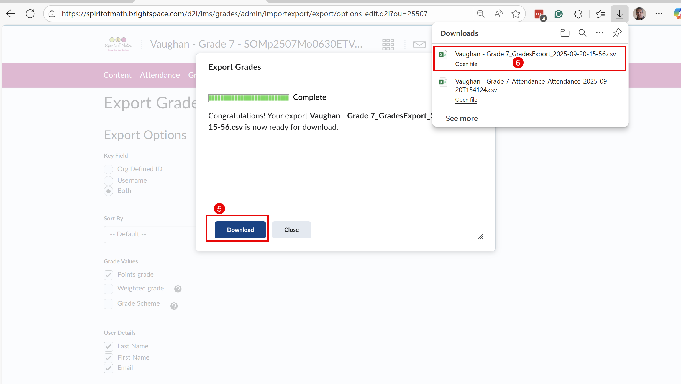

How to Download “ClassList”
Note: Make sure you are logged in to BrightSpace (ask a campus Principal to help you with this).
Download all “ClassList” files (in .html format) and copy to USB’s “ClassList” folder.
To save a file, press Control + s on a Windows or Chromebook laptop.
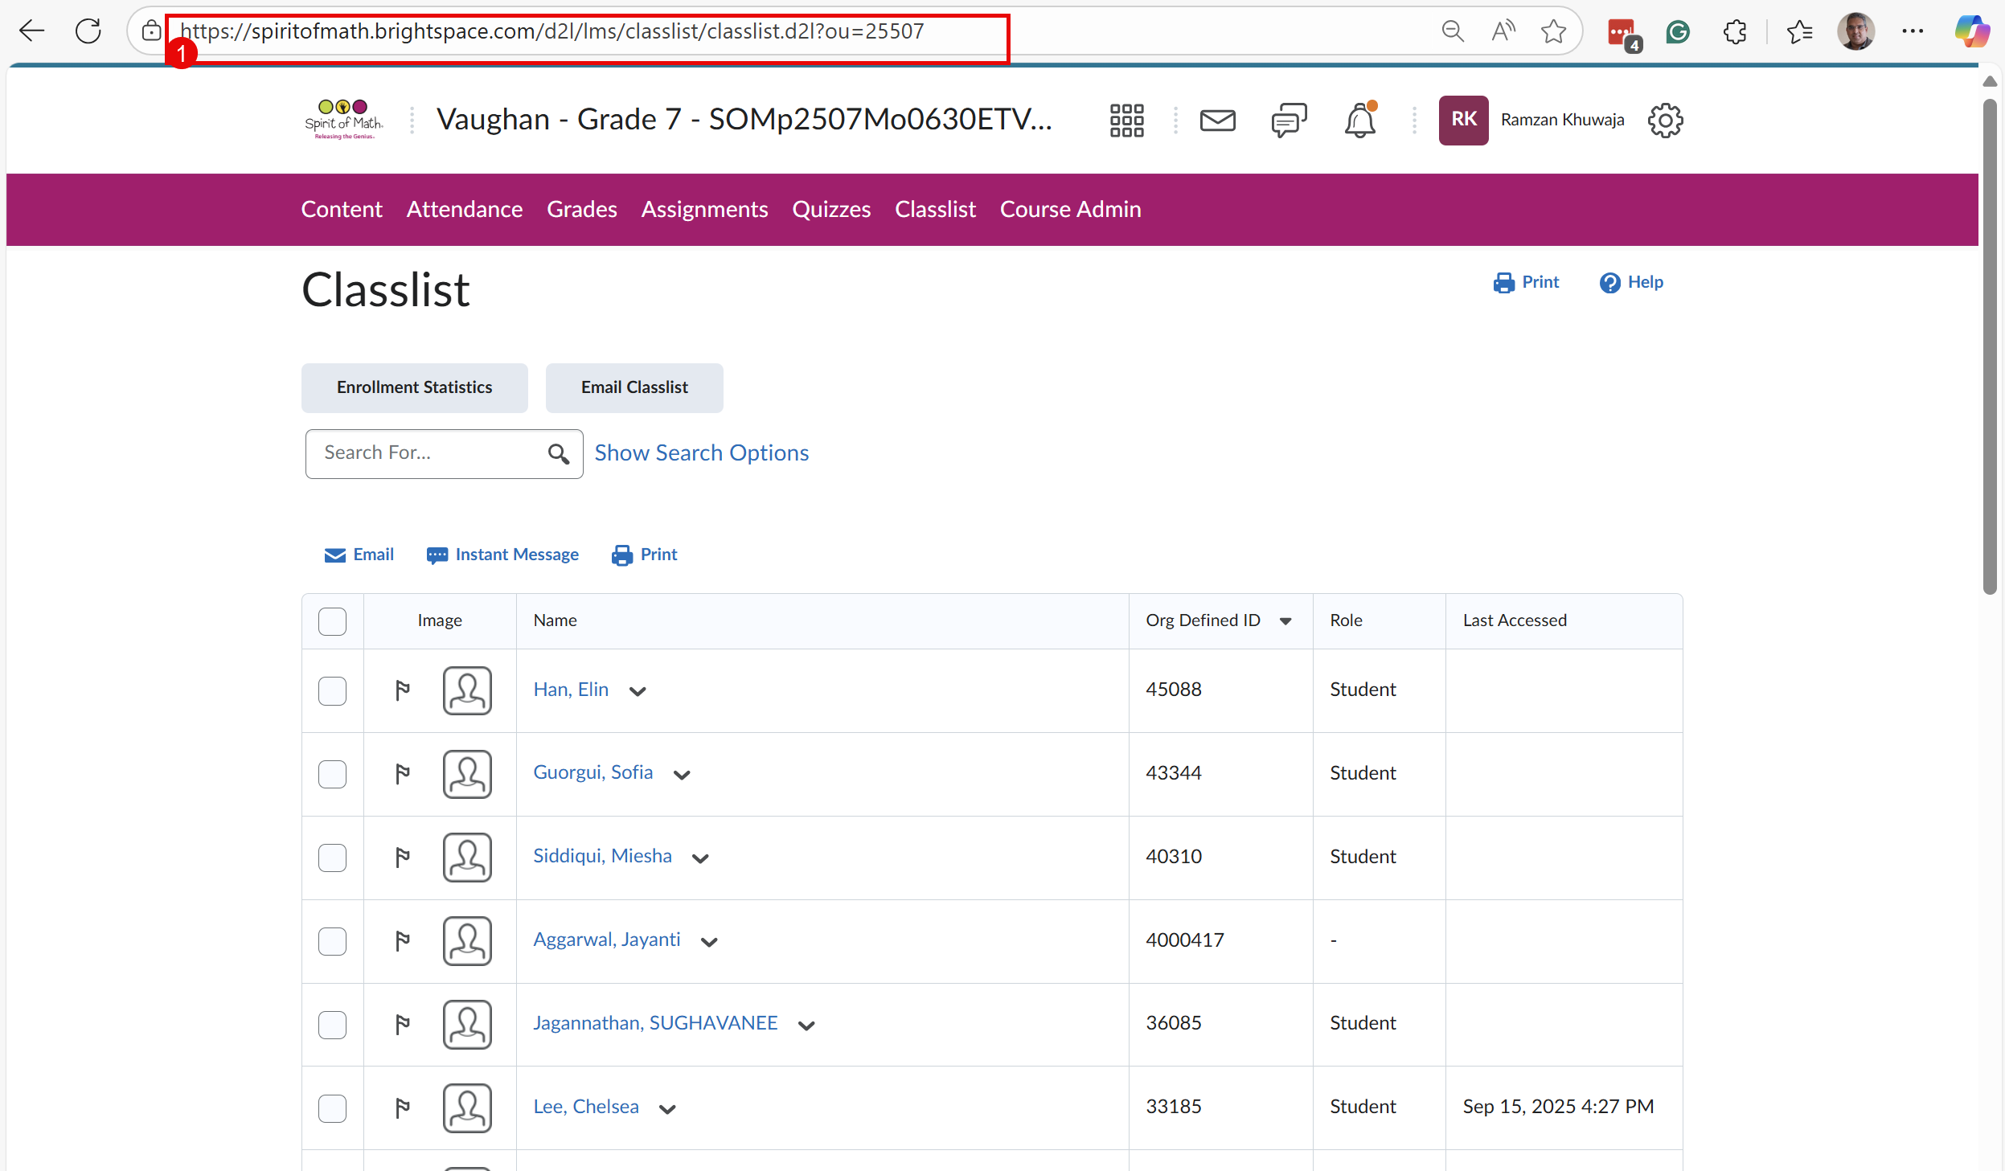

Next Step:
- Right-click on the above page and press “Save As”. Then you should see the following image.
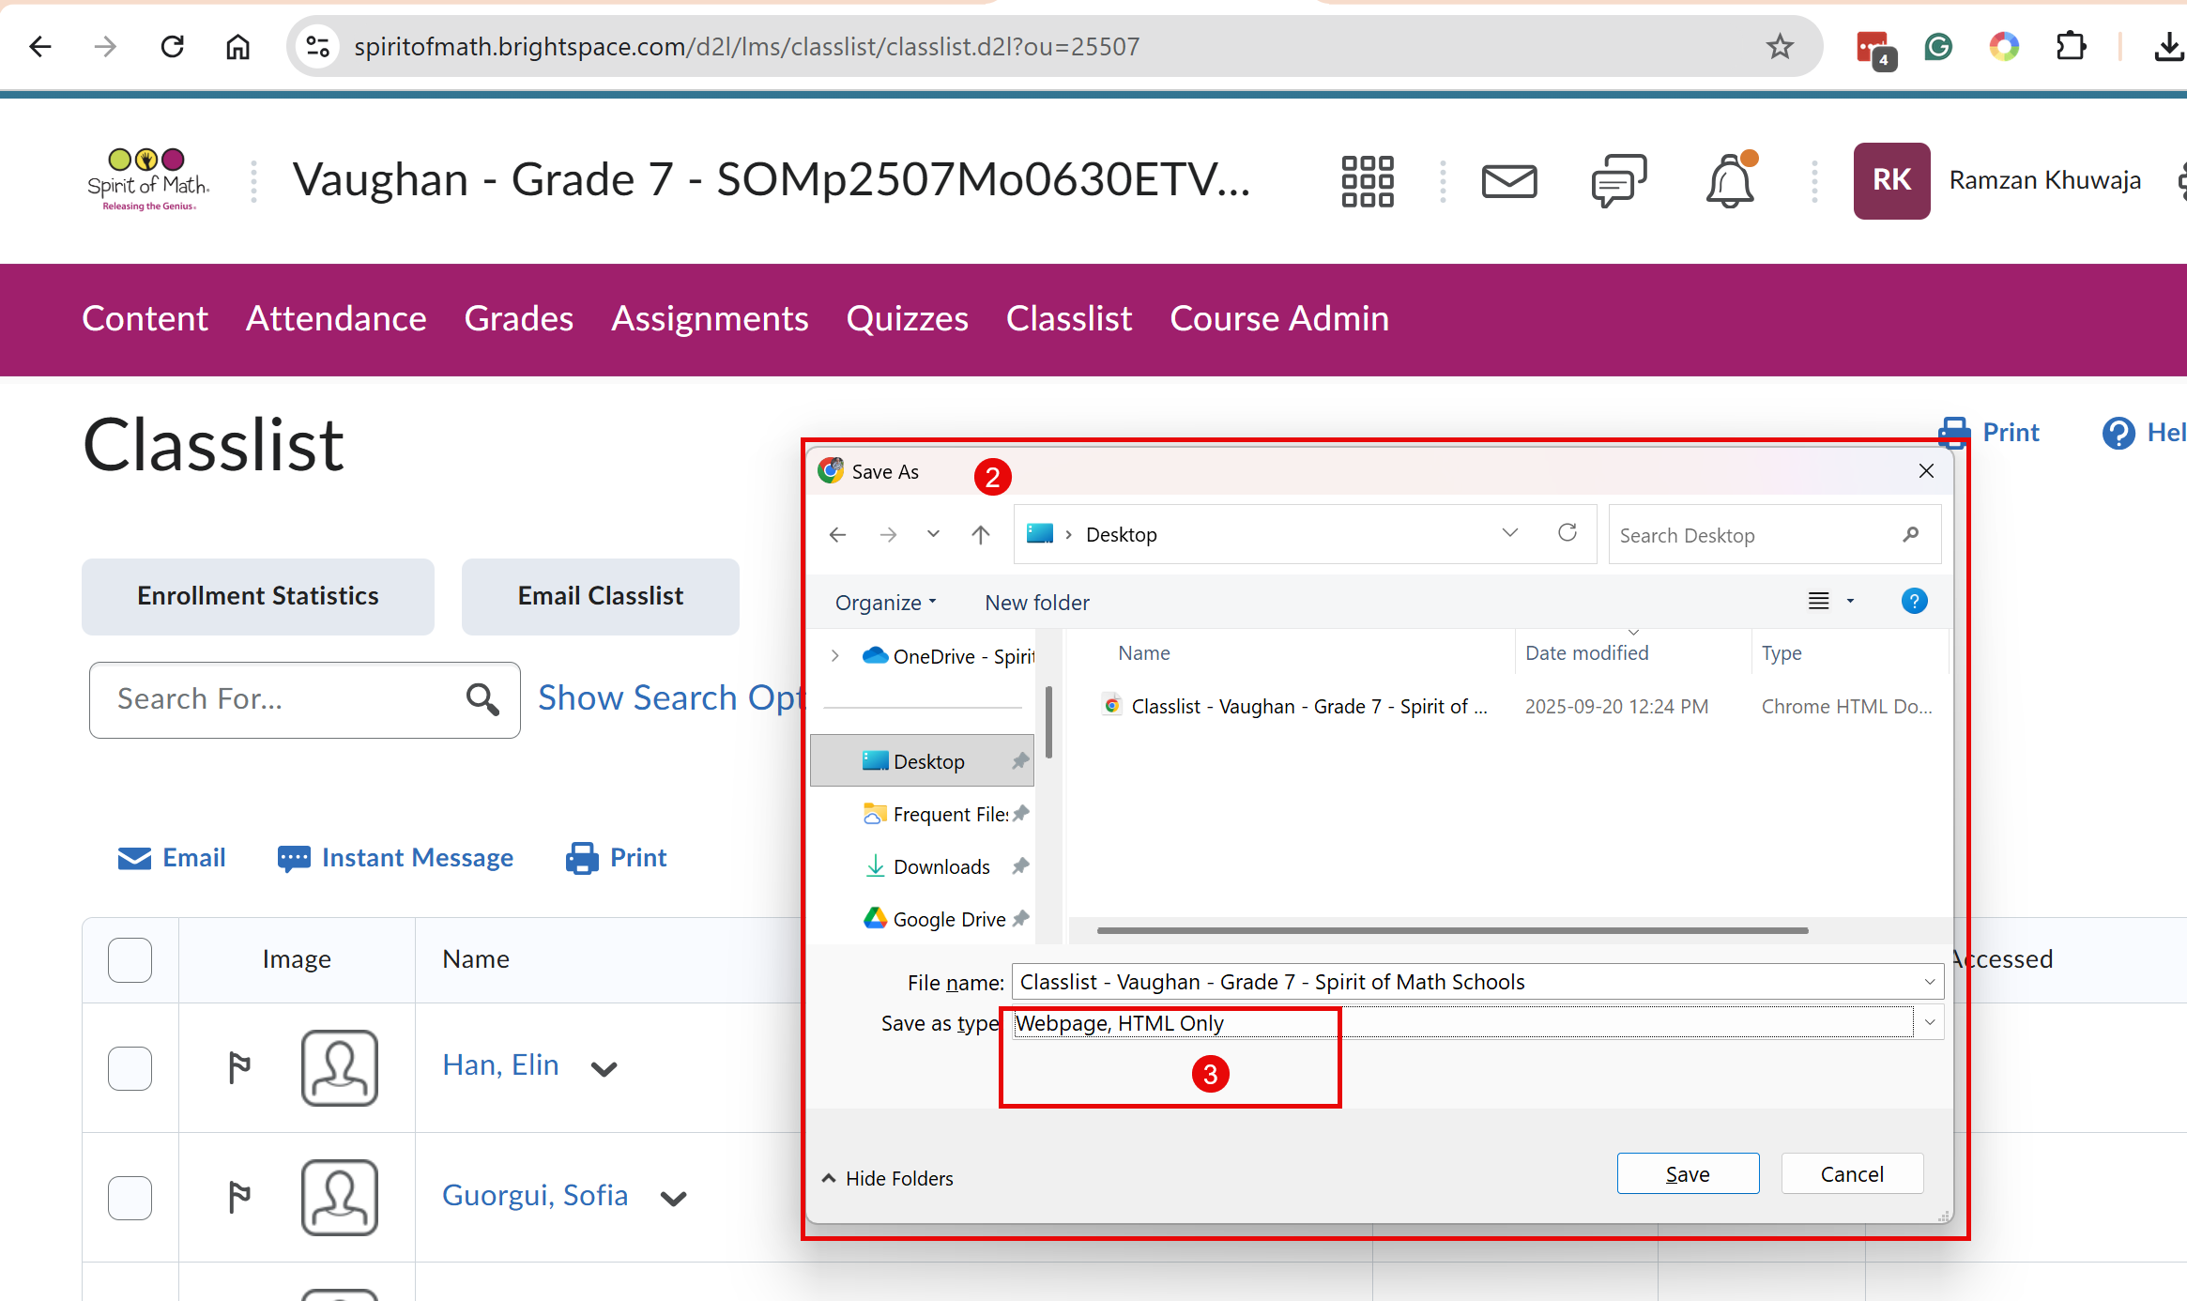

Chromebook Use

- Start with the guest login to sign in to the Chromebook
- Log in to the SoM website using the Principal Account
- Open the MAEClassMap2025-26 file (a csv or excel file) using Principal’s SoM Office account for viewing purposes.
- Now use the rest of PDF instructions (see above) and MAEClassMap2025-26 files to download data on the USB (into their proper folders)

